Subqueries (correlated and non-correlated)
What is a Subquery?
A subquery is a SQL query written inside another SQL query. The query that contains the subquery is called the outer query, and the query inside it is called the inner query (or subquery).​
The inner query runs first, produces a result, and that rSesult is then used by the outer query to complete its job.​
Think of it like this: You ask someone a question, but to answer you, they first have to ask someone else a smaller question. The answer to the smaller question helps form the final answer.
Where Can a Subquery Be Placed?
A subquery can be placed in three locations inside an outer query:​
- In the WHERE clause — to filter rows based on the subquery's result (most common use)
- In the FROM clause — to treat the subquery result as a temporary table
- In the SELECT clause — to return a calculated value for each row

Non-Correlated Subquery
A non-correlated subquery is completely independent of the outer query. It does not use any value or column from the outer query. It runs on its own, produces a result (a value or a list of values), and hands that result over to the outer query.
The outer query then uses that result to filter or compute its own output. The inner query only runs once.
How It Executes — Step by Step
- SQL sees the subquery inside parentheses.
- SQL runs the inner query first, completely independently.
- The inner query returns a result (a single value or a list of values).
- SQL substitutes that result into the outer query.
- The outer query runs using that substituted value.
Correlated Subquery
A correlated subquery is a subquery that uses a value from the outer query to run. Because it depends on the outer query's current row, it cannot run on its own — it needs the outer query to be running alongside it.
The critical difference: the inner query runs once for every single row that the outer query processes. If the outer query has 1000 rows, the inner query runs 1000 times — once per row.
​The word "correlated" means "linked." The inner query is linked to the outer query row by row.
​
The Alias Rule in Correlated Subqueries
You will always see the same table given two different aliases (like e1 and e2 in the example above). This is mandatory when the inner and outer queries both query the same table. The alias tells SQL which version of the table you are referring to at any point.​
- e1 = the outer query's version of the employees table (row-by-row scan)
- e2 = the inner query's version of the employees table (used for calculation)
Without aliases, SQL would not know which department_id belongs to the outer row and which belongs to the inner aggregation.
Correlated Subquery with EXISTS
EXISTS is one of the most common operators used with correlated subqueries. It checks whether the inner query returns any rows at all — it does not care about the actual value, just whether something exists or not.

When to Use Which
- Use a non-correlated subquery when the filter condition is based on a single fixed value or a fixed list that does not change from row to row — like the company-wide average salary, or all department IDs in a city.
- Use a correlated subquery when the filter condition must be calculated differently for each row — like each employee's department average, or whether a specific customer has orders.

in a plain correlated subquery, logically the inner query is re-run once for every outer-query row, even if the dept_id is the same.

When dept_id = 1 appears three times, the inner query:
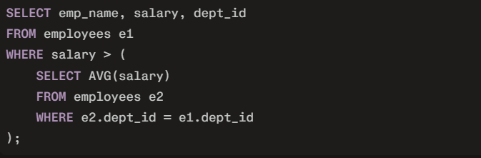
runs three separate times — once for each of those rows — and each time it computes the same average for department 1.
From your point of view as a learner, you should think:
“The subquery runs once per row. If the same department appears multiple times, the same average will be computed multiple times”
Does the database ignore “duplicate” dept_id values?
No — it does not ignore duplicates.
The database sees that dept_id = 1 occurs three times, and each time uses that value to filter the same group and compute the same average.
But conceptually you can still say:
“Every time dept_id = 1 appears in the outer query, the inner query returns the same average value for that department.”

